Insurance Fraud Detection Using Machine Learning
Epic 3: Exploratory Data Analysis

1. Exploratory Data Analysis (EDA)
Exploratory Data Analysis is the process of investigating datasets to summarize their main characteristics, often using visual methods. EDA is essential for understanding the underlying structure, detecting anomalies, testing hypotheses, and checking assumptions before building predictive models. In this project, EDA is performed to gain insights into the insurance claims data, identify patterns related to fraud, and guide feature engineering and preprocessing decisions.
1.1 Visual Analysis
Visual analysis involves creating graphical representations of data to uncover patterns, trends, and relationships that might not be apparent from summary statistics alone. Charts and plots enable intuitive understanding of distributions, outliers, and correlations. The project employs several types of visualizations tailored to different data types.
1.2 Univariate Analysis
Univariate analysis focuses on a single variable at a time. It aims to describe the distribution, central tendency, dispersion, and shape of that variable. For categorical variables, frequency counts and proportions are examined; for continuous variables, histograms, boxplots, and density plots are used.
a. Count Plot for fraud_reported
A count plot is a bar chart that displays the frequency of each category in a categorical feature. In this project, the target variable fraud_reported (indicating whether a claim is fraudulent) is visualized using a count plot. This reveals the class distribution, which is critical for understanding the balance of the dataset. A significant imbalance (e.g., few fraudulent claims compared to non-fraudulent) informs the choice of evaluation metrics (such as precision, recall, F1-score) and may necessitate resampling techniques to avoid biased models.
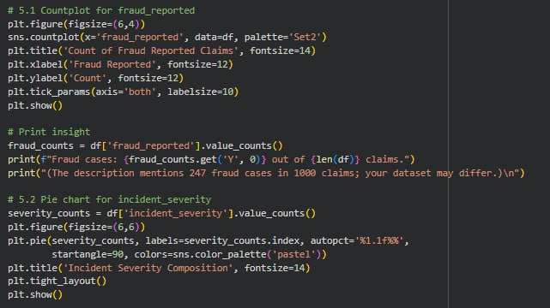
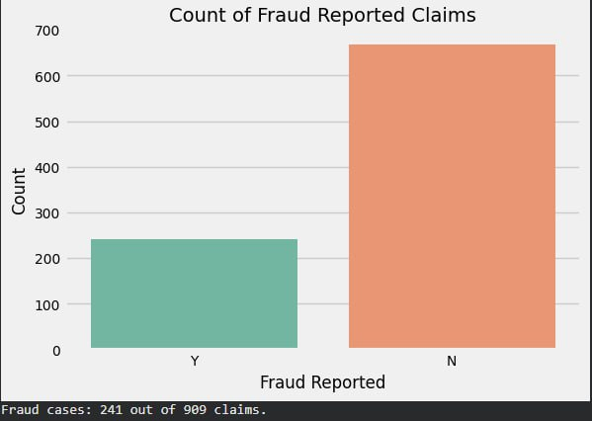

b. Pie Chart for incident_severity
A pie chart represents the proportional composition of categories within a categorical variable. Here, it shows the breakdown of incident_severity levels (Minor Damage, Major Damage, Total Loss, Trivial Damage). The percentages highlight the relative frequency of each severity type, providing insight into the typical nature of incidents that lead to claims. Such information can be useful for feature engineering and for understanding which severity levels are more prone to fraud.
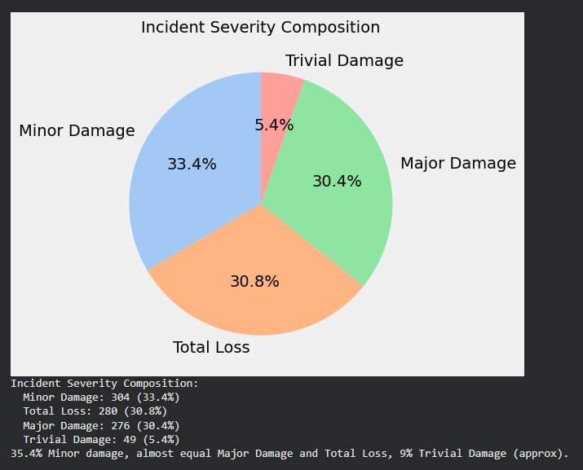

c. Histogram and Q-Q Plot for age
A histogram with a kernel density estimate (KDE) visualizes the distribution of a continuous variable by grouping data into bins. It helps identify skewness, modality, and the presence of outliers. In this project, the age of claimants is examined. The superimposed KDE curve smooths the histogram to approximate the probability density function.
A Q-Q (quantile-quantile) plot compares the empirical quantiles of the data against the quantiles of a theoretical distribution (here, the normal distribution). If the points lie approximately along the reference line, the data can be considered normally distributed. Assessing normality is important because some statistical tests and machine learning algorithms (e.g., linear discriminant analysis) assume normality, though tree-based models are robust to deviations. The observation that age is roughly normal is a useful diagnostic for later modeling steps.

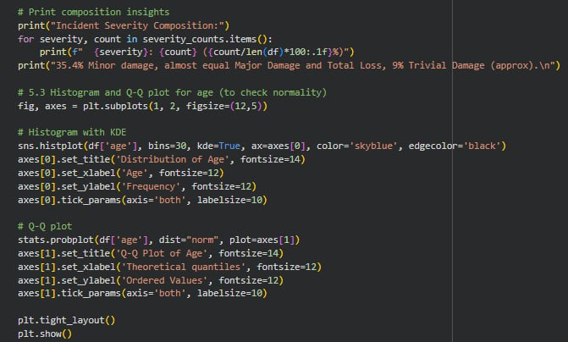

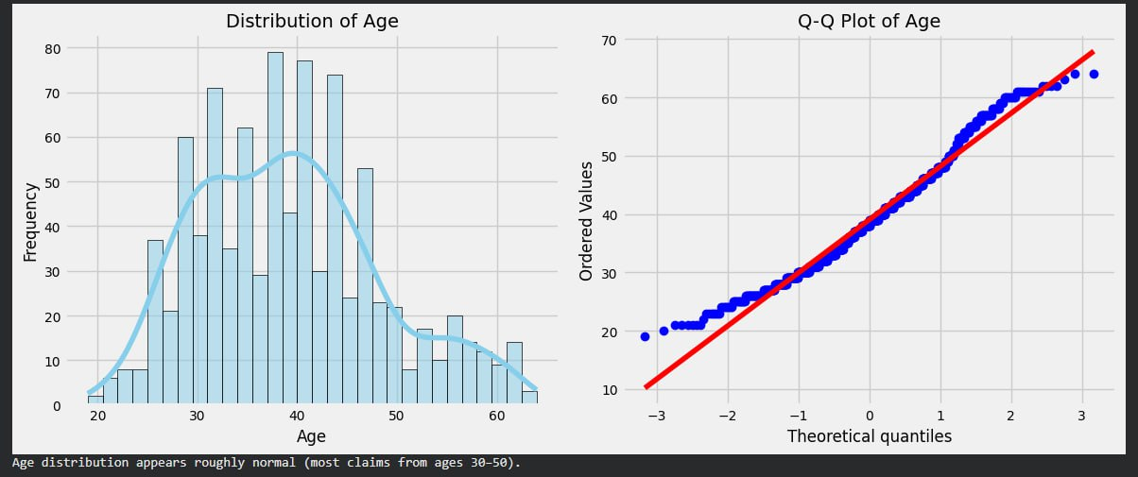

1.3 Multivariate Analysis
Multivariate analysis explores relationships among multiple variables simultaneously. It helps identify dependencies, interactions, and potential multicollinearity, which can affect model performance and interpretability.
a. Correlation Heatmap
A correlation matrix quantifies the linear relationship between pairs of numeric features using the Pearson correlation coefficient. Values range from -1 (perfect negative linear relationship) to +1 (perfect positive linear relationship), with 0 indicating no linear correlation. A heatmap visualizes this matrix, with color intensity representing the strength of correlation. This allows quick identification of clusters of highly correlated features.
In this project, a correlation heatmap is generated for all numeric columns. The visual reveals strong positive correlations between certain variables, such as months_as_customer and age, as well as among claim amount components (injury_claim, property_claim, vehicle_claim) and total_claim_amount.
b. Detecting Highly Correlated Pairs
A threshold (e.g., absolute correlation > 0.8) is set to flag feature pairs that are nearly collinear. These pairs indicate redundancy: the variables convey similar information, and including both can lead to multicollinearity, which inflates variance in linear models and can degrade performance in some algorithms. By printing these pairs, the analyst can make informed decisions about feature selection.
c. Dropping Highly Correlated Features
To mitigate multicollinearity and reduce dimensionality, one feature from each highly correlated group is retained while the others are dropped. The choice of which feature to keep is based on domain knowledge and practical considerations. For instance, age is kept over months_as_customer because age is a more fundamental demographic attribute. Similarly, total_claim_amount is retained as it aggregates the information from the individual claim components. This step simplifies the model, improves interpretability, and can enhance generalization.

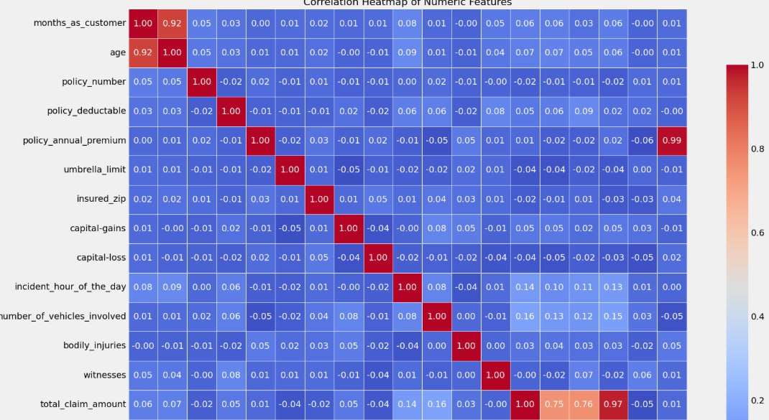

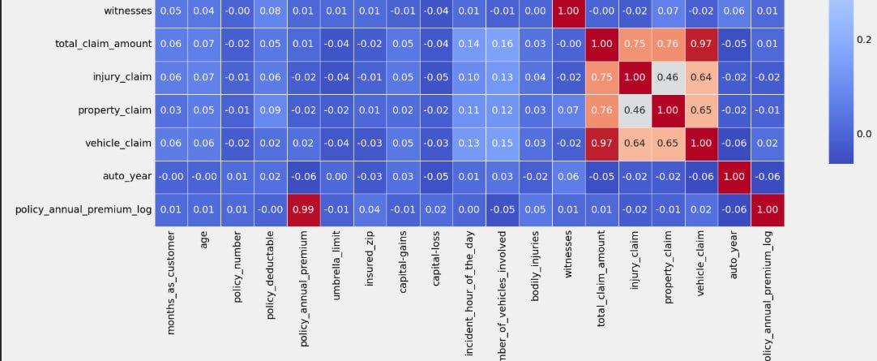

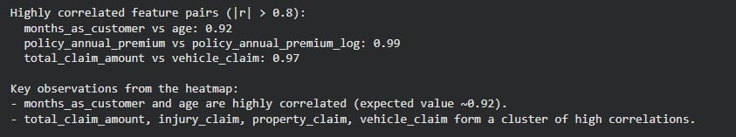

2. Encoding Categorical Features
Machine learning algorithms operate on numerical data. Categorical features, which consist of discrete categories or labels, must be converted into numeric form before they can be used as inputs. This process is known as encoding.
2.1 Why Encoding is Necessary
Most algorithms (e.g., linear regression, neural networks, support vector machines) require numerical inputs to perform mathematical operations. Even tree-based models, which can handle categorical data natively in some implementations, often expect numerical inputs in standard libraries like scikit-learn. Encoding transforms categorical values into numbers while preserving the information they contain.
2.2 Label Encoding
Label encoding assigns a unique integer to each category in a feature. For example, a feature with categories ['Red', 'Green', 'Blue'] might be encoded as [0, 1, 2]. This method is simple and memory-efficient.
When to Use: Label encoding is appropriate for ordinal categorical variables where there is a natural order (e.g., education level: 'High School' < 'Bachelor' < 'Master'). For nominal variables without order, label encoding can inadvertently introduce an ordinal relationship that does not exist, potentially misleading some algorithms. However, for tree-based models, this is often acceptable because trees make splits based on ordering.
In this project, all categorical columns (identified by object dtype) are label-encoded using scikit-learn's LabelEncoder. The encoder is fitted on the entire dataset, and the mapping is stored for later use (e.g., when transforming new data for prediction). This ensures consistency between training and inference.
2.3 Alternative Encoding Methods
While label encoding is used here, other encoding techniques exist:
- One-Hot Encoding: Creates binary columns for each category, avoiding ordinal assumptions but increasing dimensionality.
- Target Encoding: Replaces categories with the mean of the target variable for that category, useful for high-cardinality features.
- Ordinal Encoding: Similar to label encoding but with a predefined order.
The choice of encoding depends on the algorithm and the nature of the categorical variable.
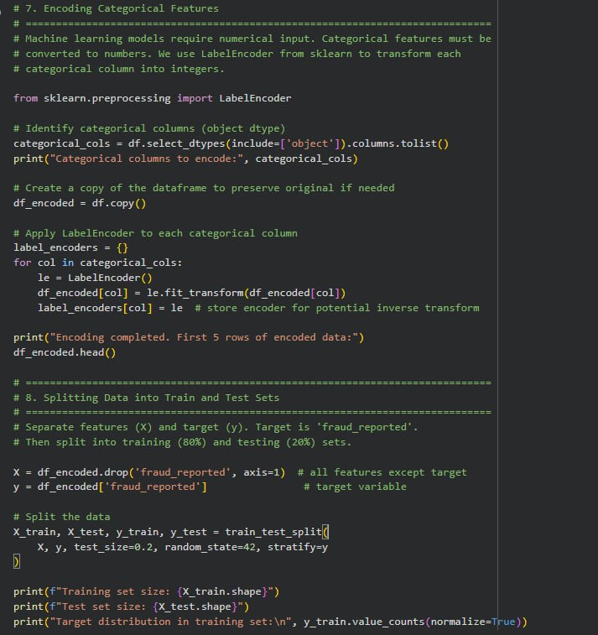

3. Splitting Data into Training and Testing Sets
To evaluate the performance of a machine learning model on unseen data, the dataset is divided into two subsets: a training set used to train the model, and a test set used to assess its generalization ability. This simulates how the model will perform on new, real-world data.
3.1 Purpose of Train-Test Split
Without a separate test set, a model could simply memorize the training data (overfitting) and achieve high accuracy while failing on new instances. By withholding a portion of the data during training and evaluating on it afterward, we obtain an unbiased estimate of model performance.
3.2 Stratification
When the target variable is imbalanced (e.g., few fraudulent claims), it is important to maintain the same class proportions in both training and test sets. This is achieved through stratification. In the code, the stratify=y parameter ensures that the random split preserves the original distribution of fraud_reported. Without stratification, the test set might end up with very few or no instances of the minority class, making evaluation unreliable.
3.3 Random State for Reproducibility
The random_state parameter (e.g., random_state=42) sets a seed for the random number generator, ensuring that the split is reproducible. Running the code multiple times with the same seed yields identical train-test partitions, which is essential for consistent experimentation and debugging.
3.4 Typical Split Ratio
A common practice is to allocate 80% of the data for training and 20% for testing, as done in this project. The exact ratio can vary based on dataset size, but 80/20 is a standard starting point. The training set size and test set size are printed to confirm the split.
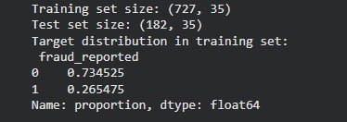

4. Feature Scaling
Feature scaling is a preprocessing technique that standardizes the range of independent variables. Many machine learning algorithms perform better or converge faster when features are on a similar scale.
4.1 Why Scaling is Important
- Distance-Based Algorithms: Algorithms like k-nearest neighbors (KNN) and support vector machines (SVM) rely on distance calculations (e.g., Euclidean distance). If one feature has a larger magnitude than others, it will dominate the distance metric, biasing the model. Scaling ensures all features contribute equally.
- Gradient Descent: Algorithms that use gradient descent (e.g., logistic regression, neural networks) converge faster when features are scaled, as the loss surface becomes more spherical.
- Regularization: Regularization terms (e.g., L1/L2 penalty) penalize coefficients based on their magnitude. Without scaling, features with larger scales are penalized unfairly.
- Tree-Based Models: Decision trees and ensemble methods like random forests are generally scale-invariant, as they make splits based on feature order rather than magnitude. However, scaling is often applied uniformly for consistency and to allow easy switching between algorithms.
4.2 StandardScaler
StandardScaler standardizes features by removing the mean and scaling to unit variance. The transformation is given by:
$$x_{\text{scaled}}=\frac{x-μ}{σ}$$
where $μ$ is the mean and $σ$ is the standard deviation of the feature in the training set.
Key Points:
- The scaler is fitted only on the training set to compute $μ$ and $σ$. This prevents data leakage, where information from the test set influences the training process.
- The same $μ$ and $σ$ are then used to transform both the training and test sets. This ensures that the test data is scaled consistently with the training data, even if its own distribution differs slightly.
- After scaling, each feature has a mean of approximately 0 and a standard deviation of 1, assuming the original data was normally distributed. This is verified by printing the mean and standard deviation of the scaled training set.
4.3 Comparison with Other Scalers
- MinMaxScaler: Scales features to a fixed range, usually [0, 1]. It is sensitive to outliers.
- RobustScaler: Uses median and interquartile range, making it robust to outliers.
- Normalizer: Scales individual samples to unit norm (row-wise scaling), useful for text classification or when similarity between samples is measured by cosine distance.
StandardScaler is chosen in this project because it centers the data and is a good default for many algorithms.
